COMBINED MOVEMENT THEORY · CLINICAL REASONING FORM
PATIENT IDENTIFIER | DATE | CLINICIAN
A SAFETY, CONSENT AND NEUROLOGICAL SCREEN complete before any passive testing
A1 Red flag screen ☐ no concerning features ☐ features present
A2 Neurological examination ☐ not indicated ☐ limbs: LMN / UMN ☐ limbs and cranial nerves
A3 Consent ☐ nature, risks, alternatives discussed; consent given
B HYPOTHESES AND CONTRIBUTING DOMAINS
B1 Two competing hypotheses for the impairment
H1
H2
B2 Relative contribution of each domain today ‡ 0 none · 1 possible · 2 contributory · 3 substantial · 4 dominant
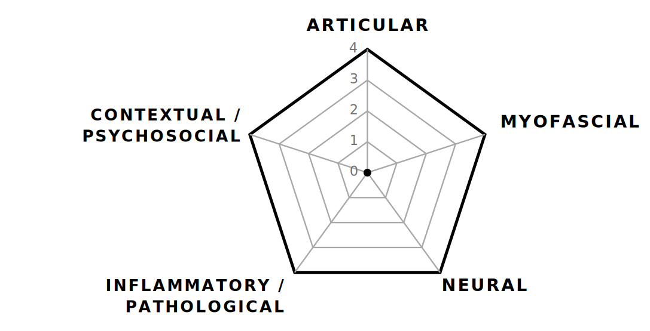 | B3 Severe? † ☐ yes ☐ no  Irritable? ☐ yes ☐ no  B4 Dominant pain mechanism  ☐ nociceptive  ☐ neuropathic  ☐ nociplastic  ☐ mixed — specify
C EXAMINATION AND TREATMENT PLAN
C1 Comparable sign and retest marker — state the movement or function tested, and the measure used

C2 Passive testing taken to ☐ first onset of symptoms ☐ limit of the impairment
Starting position ☐ prime combination (PC) ☐ opposite quadrant to PC ☐ other
C3 Candidate interventions state position, direction, grade and dose (IN: position · WILL: do)
H1
H2
D RESULT OF TODAY’S TEST, AND REASONING
D1 Retest marker % change ☐ worse ☐ no change ☐ better
D2 Hypothesis better supported ☐ H1 ☐ H2 ☐ neither — revise both
D3 Home programme, take-home message and comments

E PLAN FOR THE NEXT VISIT what you will do if the marker is
BETTER | SAME | WORSE
† Severe: intensity sufficient to stop the activity. Irritable: little activity provokes symptoms, which take a long time to settle — usually a nociplastic presentation. Judge both from today’s history.
‡ B2 is an ordinal clinical judgement, not a measurement.
CMT Clinical Reasoning Form, second edition · Combined Movement Institute UK Page ______ of the clinical record

